C. DIFFICILE INFECTION (CDI) PREVENTION COLLABORATIVE
Healthcare-Acquired CDI Rate = Number of Lab-identified HA-CDI Cases / 10,000 Patient Days
Trend line shows rates over time - - - Number indicates # of lab-identified HA-CDI cases each month
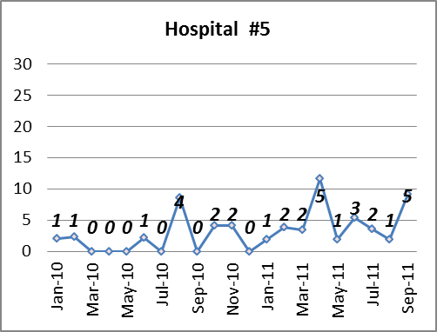
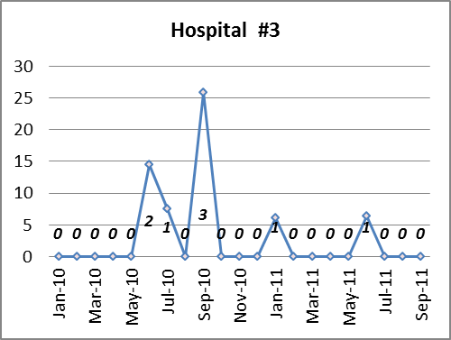
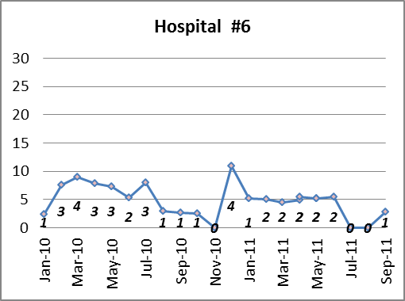
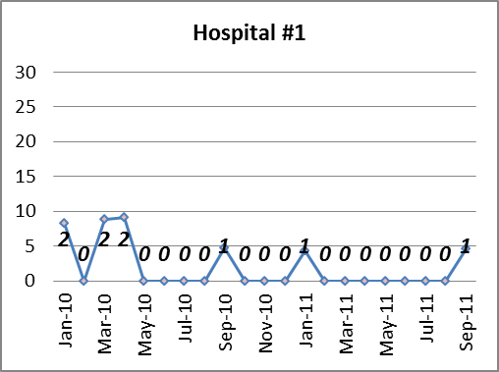
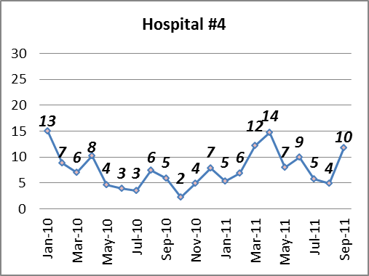
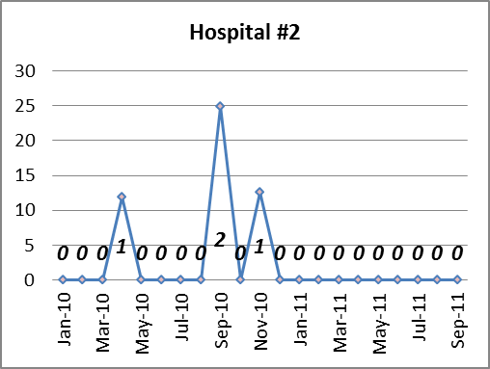

C. DIFFICILE INFECTION (CDI) PREVENTION COLLABORATIVE
Healthcare-Acquired CDI Rate = Number of Lab-identified HA-CDI Cases / 10,000 Patient Days
Trend line shows rates over time - - - Number indicates # of lab-identified HA-CDI cases each month
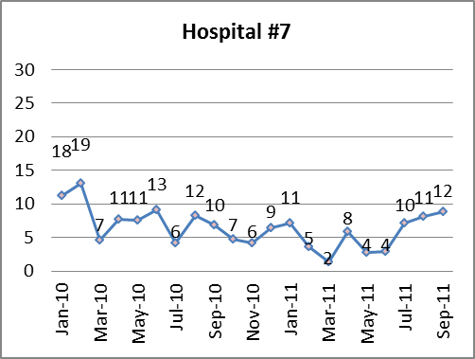
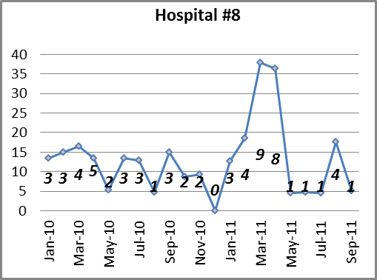

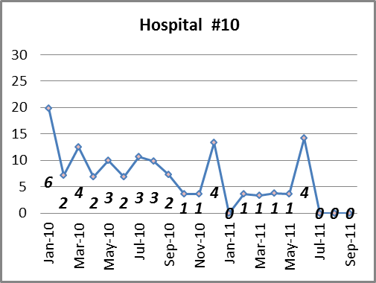
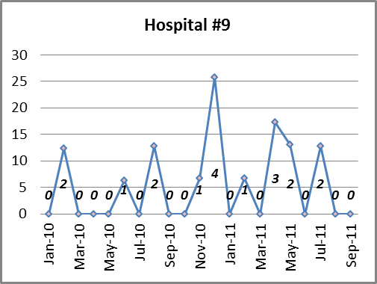

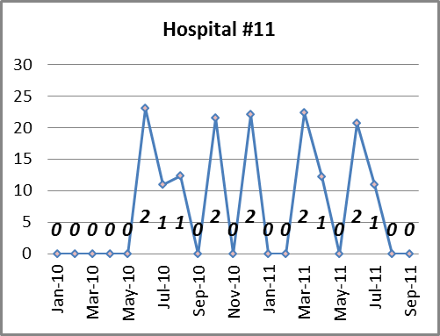
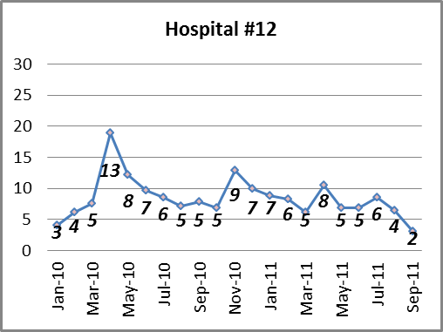

C. DIFFICILE INFECTION (CDI) PREVENTION COLLABORATIVE
Healthcare-Acquired CDI Rate = Number of Lab-identified HA-CDI Cases / 10,000 Patient Days
Trend line shows rates over time - - - Number indicates # of ldentified HA-CDI cases each month
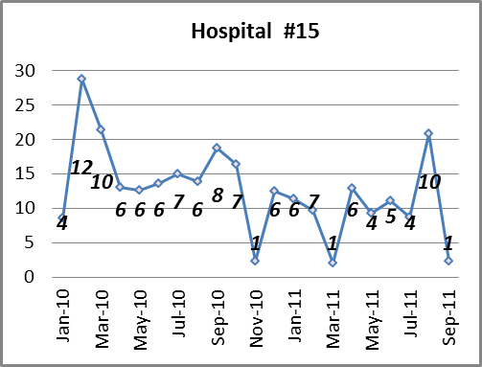
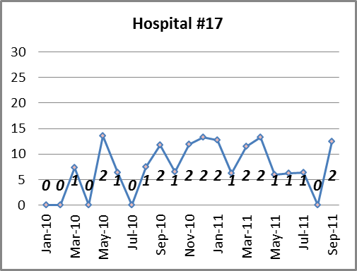
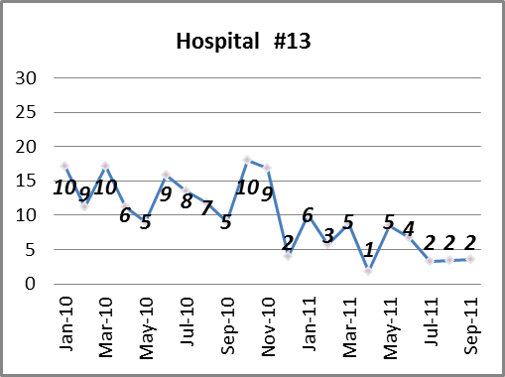
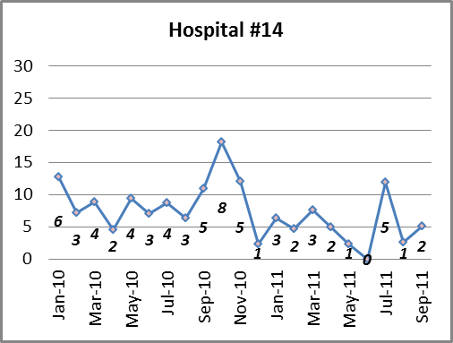

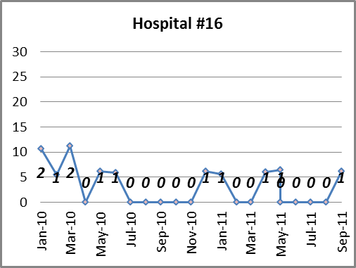
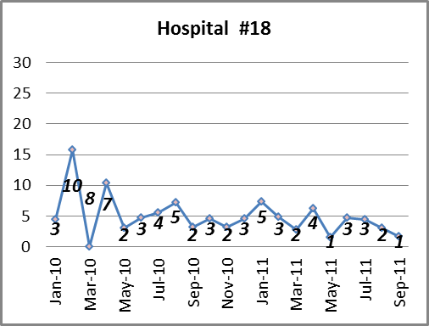

C. DIFFICILE INFECTION (CDI) PREVENTION COLLABORATIVE
Healthcare-Acquired CDI Rate = Number of Lab-identified HA-CDI Cases / 10,000 Patient Days
Trend line shows rates over time - - - Number indicates # of ldentified HA-CDI cases each month
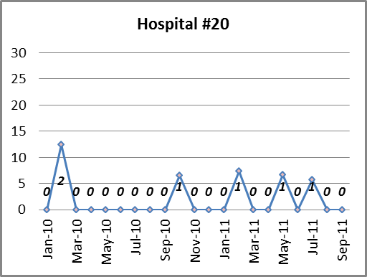
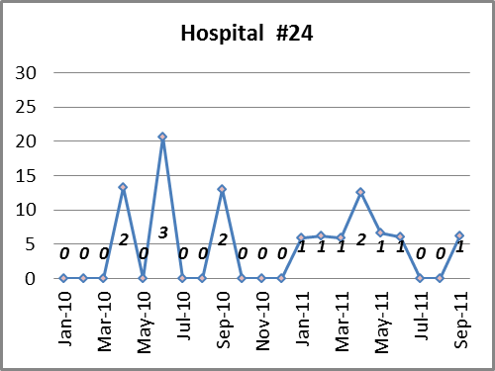
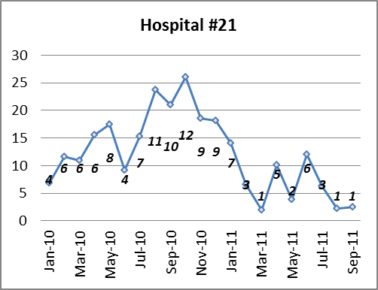
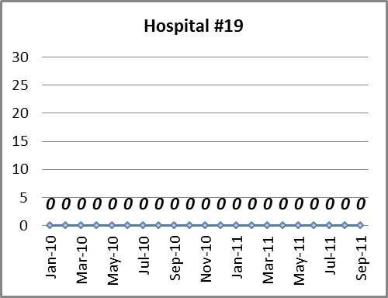
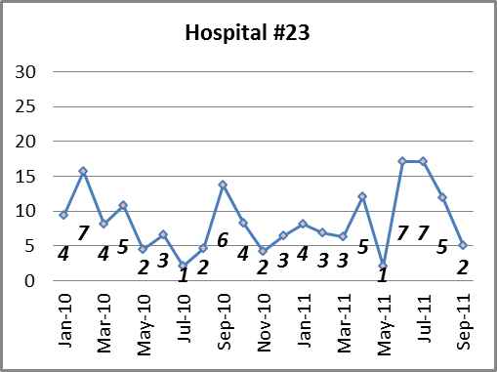
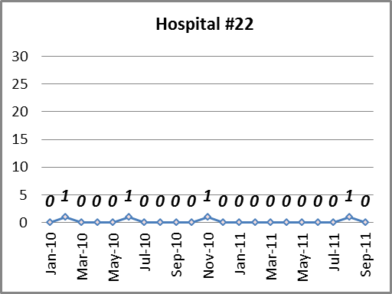

C. DIFFICILE INFECTION (CDI) PREVENTION COLLABORATIVE | C. DIFFICILE INFECTION (CDI) PREVENTION COLLABORATIVE | C. DIFFICILE INFECTION (CDI) PREVENTION COLLABORATIVE | C. DIFFICILE INFECTION (CDI) PREVENTION COLLABORATIVE | C. DIFFICILE INFECTION (CDI) PREVENTION COLLABORATIVE | C. DIFFICILE INFECTION (CDI) PREVENTION COLLABORATIVE | C. DIFFICILE INFECTION (CDI) PREVENTION COLLABORATIVE | C. DIFFICILE INFECTION (CDI) PREVENTION COLLABORATIVE | C. DIFFICILE INFECTION (CDI) PREVENTION COLLABORATIVE | C. DIFFICILE INFECTION (CDI) PREVENTION COLLABORATIVE | C. DIFFICILE INFECTION (CDI) PREVENTION COLLABORATIVE
Healthcare-Acquired CDI Rate = Number of Lab-identified HA-CDI Cases / 10,000 Patient Days
Trend line shows rates over time - - - Number indicates # of ldentified HA-CDI cases each month
